**Deploy source local**

1. Cài đặt docker

Download Docker tại [đây](https://download.docker.com/win/stable/Docker%20Desktop%20Installer.exe)

Sau khi download thành công, tiến hành cài đặt như những app destop bình thường.

Sau khi cài đặt thành công, docker sẽ yêu cầu restart.

Sau khi restart, docker sẽ yêu cầu login, bạn có thể login hoặc không

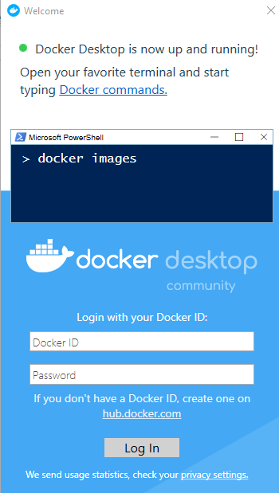

Dưới thanh taskbar, sẽ có biểu tưởng docker running (dấu hiệu là docker đã chạy thành công)

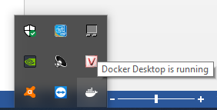

Chech thử version của docker và docker compose nhé:

* Hoàn thành bược cài đặt và chạy docker.

1. Chạy các service docker

Tại folder có cấu trúc file như bên dưới, mở comman line:

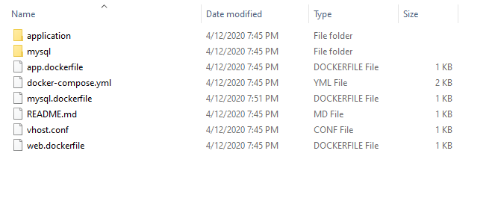

Chạy lệnh sau: docker-compose up –build

Lúc này docker sẽ cài đặt và chạy các service được config. Khi build lần đầu sẽ mất 1 đoạn thời gian

Trong quá trình cài đặt, docker sẽ yêu cầu cấp quyền share folder, ta sẽ click Share it nhé

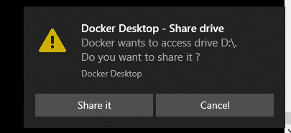

Sau đó quá trình sẽ dừng lại như hình bên dưới

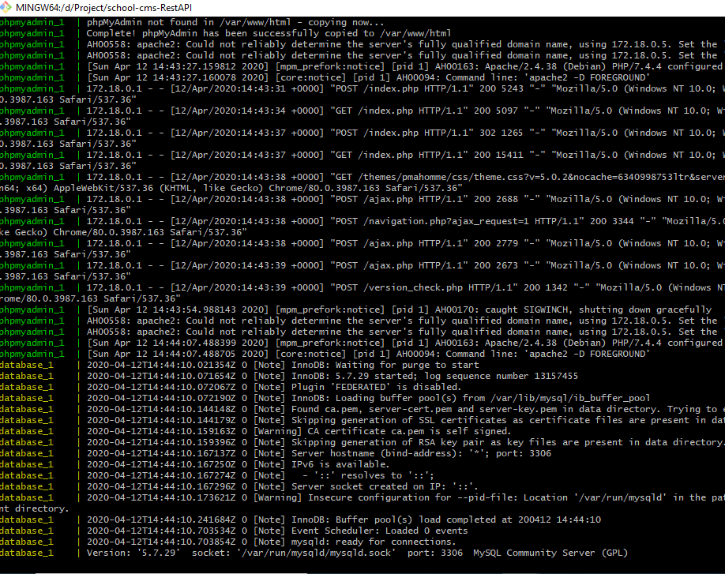

Ta sẽ mở 1 command line nữa để check các service nhé

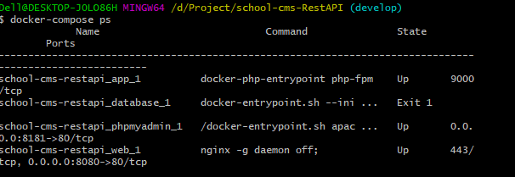

* Các server đã được cài đặt và chạy thành công

PhpMyadmin: (root/root)

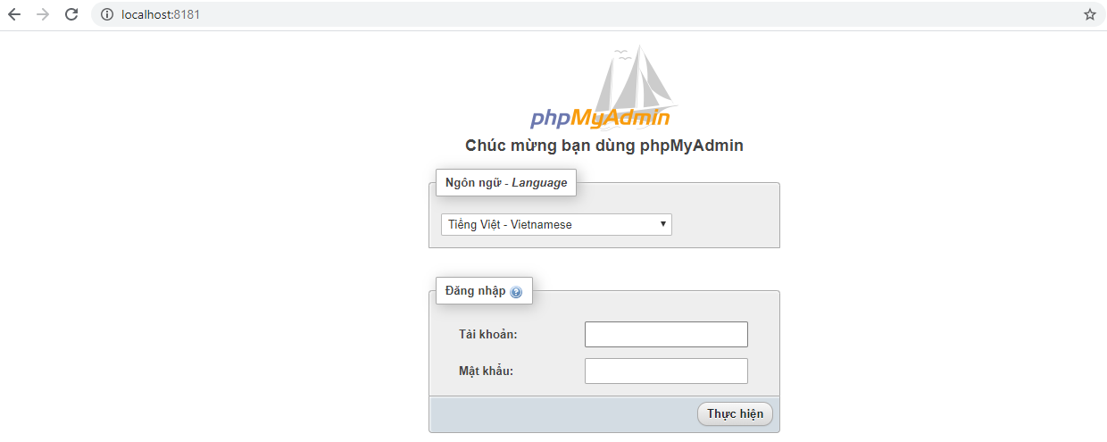

Web

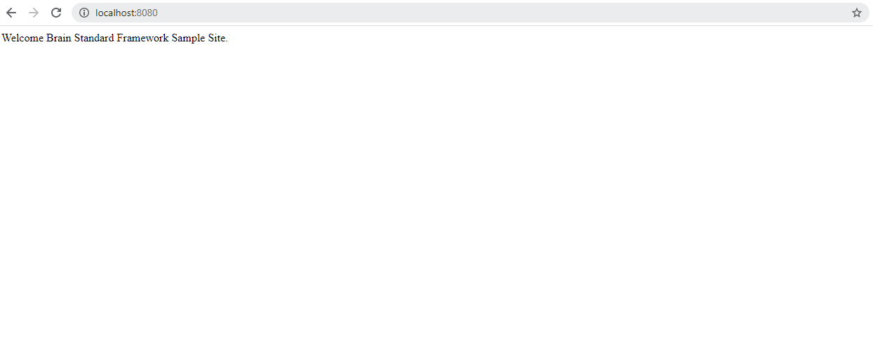

## Đối với Docker Toolbox

* Cài đặt xong chạy Docker Quickstart Terminal
* cd vô folder source cms
* chạy lệnh docker-compose up -d
* Chạy 192.168.99.100:8080/api/notice thì gọi được api

Docker sẽ chạy link IP4 của máy ảo (192.168.99.100) thay vì localhost  
muốn đổi thành localhost thì tham khảo:   
<https://www.jhipster.tech/tips/020_tip_using_docker_containers_as_localhost_on_mac_and_windows.html>

* Với lần chạy đầu sẽ không build dc fake Database

Phải chạy lệnh: winpty docker-compose exec app php artisan db:seed

Các lỗi thường gặp khi chạy docker

If the features described are enabled the problem is with Hyper-V that is disabled or Hypervisor agent not running SOLUTION A (If Hyper-V is totally disabled or not installed) Open PowerShell as administrator and Enable Hyper-V with dism.exe /Online /Enable-Feature:Microsoft-Hyper-V /All SOLUTION B (If Hyper-V feature is already enabled but doesn't work) Enable Hypervisor with bcdedit /set hypervisorlaunchtype auto Now restart the system and try again. SOLUTION C If the problem persists probably Hyper-V on your system is corrupted, so Go in Control Panel -> [Programs] -> [Windows Features] and completely uncheck all Hyper-V related components. Restart the system. Enable Hyper-V again. Restart. NOTE 1: Hyper-V needs hardware virtualization as prerequisite. Make sure your PC supports it, if yes and still won't work there is the possibility your BIOS is not configured correctly and this feature is disabled. In this case, check, enable it and try again. The virtualization features could be reported under different names according the platform used (e.g if you don't see any option that uses virtualization label explicitly, on AMD you have to check SVM feature state, on Intel the VT-x feature state). NOTE 2: Hyper-V can be installed only with some version e.g.: Windows 10 Enterprise; Windows 10 Professional; Windows 10 Education. Hyper-V cannot be installed on cheaper or mobile Windows versions e.g.: Windows 10 Home; Windows 10 Mobile; Windows 10 Mobile Enterprise.

<https://stackoverflow.com/questions/39684974/docker-for-windows-error-hardware-assisted-virtualization-and-data-execution-p>

Fix lỗi khi không mở được docker